**TERMS OF REFERENCE**

**for the purchase of a CIMC low-bed semi-trailer for Mine Operations Department, Kumtor Gold Company CJSC**

|  |  |  |
| --- | --- | --- |
| **Item**  **№** | **List of basic**  **data and requirements** | **Basic data and requirements** |
| 1. | Delivery location | Issyk-Kul Region, Jeti-Oguz District, Kumtor Gold Mine |
| 2. | Client | Kumtor Gold Company CJSC |
| 3. | Subject of the purchase | Semi-trailer to transport pit equipment, wheeled and tracked machinery. |
| 4. | Purpose of the purchase | Replacement of obsolete equipment. |
| 5. | General requirements/  Regulations and standards | 1. The trailer shall be wheeled with a minimum load capacity of 85 tons for operation on the mine's pit roads. 2. Parameters of the trailer shall be as follows:  * width of working platform shall be at least 3,800 mm, * length of working platform shall be at least 6,500 mm.  1. Towing hitch (Kingpin 2-3 1/2") for Volvo FMX 460 truck tractor-based towing. 2. Suspension with balanced axles is provided in Appendix 1. ІЅО10х335 3. Trailer design is provided in Appendix 2. 4. All necessary documentation (certificates, passports, etc.) in accordance with the regulations and standards of the Kyrgyz Republic (EAEU) shall be available. |
| 6. | Individual requirements | 1. The semi-trailer shall be able to operate in high altitude conditions above 4,000 m above sea level, at the temperatures from - 40℃ to +40℃ (pneumatic braking systems shall be adapted to cold conditions). 2. Coupling and uncoupling design of the semi-trailer with the truck tractor shall ensure safe, quick, and reliable fixation with minimum human resource involvement. 3. The semi-trailer shall ensure safe and reliable fixation of equipment during transportation (fixation and external influence protection systems shall be available. 4. The semi-trailer shall be equipped with a balancing system to compensate for vibrations that occur during transportation on uneven surface. 5. The semi-trailer shall be equipped with a pneumatic braking system with the possibility of connecting a Volvo FMX 460 based tractor. 6. Tires 12.00R-20 shall have appropriate treads to operate in mountain conditions. |
| 7. | Payment and delivery terms | 1. 50% prepayment and 50% payment after commissioning. 2. The semi-trailer shall be delivered by the manufacturer to the BMY within the deadlines specified by the Client. 3. The semi-trailer shall be assembled and commissioned by the manufacturer within the deadlines specified by the Client. 4. In case of failure to comply with the terms, penalties shall apply. |
| 8. | Warranty period | 1. The Supplier shall provide a warranty period for the purchased equipment in accordance with the manufacturer's terms and conditions. |
| 9. | Client's services | 1. The manufacturer's employees performing assembling and debugging of the trailer at the mine site will be accommodated in the residential camp. 2. Internal transport. 3. Meals. 4. Additional services will be provided upon prior request of the Contractor for a separate fee. |
| 10. | Assembly, acceptance, transfer, and commissioning | 1. The Supplier shall complete assembly, adjustment, and commissioning work in full. 2. Acceptance Certificate shall be signed after the semi-trailer has been fully assembled and commissioned. 3. All costs for additional work identified during the equipment inspection shall be borne by the Supplier. |
| 11. | Training and operation manual | 1. The Supplier shall train personnel on maintenance and operation of the semi-trailer. 2. Operation manual for the semi-trailer (electronic, paper version) shall be provided (including in Russian language). 3. Spare parts catalogue (electronic, paper version) shall be provided. |
| 12. | Quality evaluation criteria | 1. After commissioning, the equipment shall be evaluated during the warranty period and shall comply with the manufacturer's stated specifications. 2. In the event of non-compliance with the requirements, the manufacturer shall bear all costs for its elimination. |
| 13. | Confidentiality | 1. The transaction data shall be confidential. The Contractor shall be liable for disclosure to third parties. |
| 14. | Environmental requirements | 1. All works shall be conducted in accordance with the KGC internal regulations. |
| 15. | Safety | 1. The semi-trailer shall comply with the safety requirements established by the applicable legislation of the Kyrgyz Republic. 2. All works shall be conducted in accordance with the KGC internal regulations. |

Appendix 1:

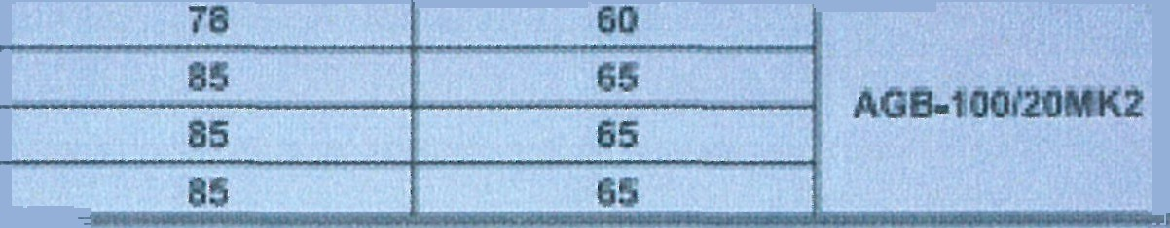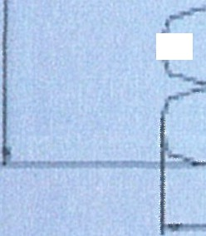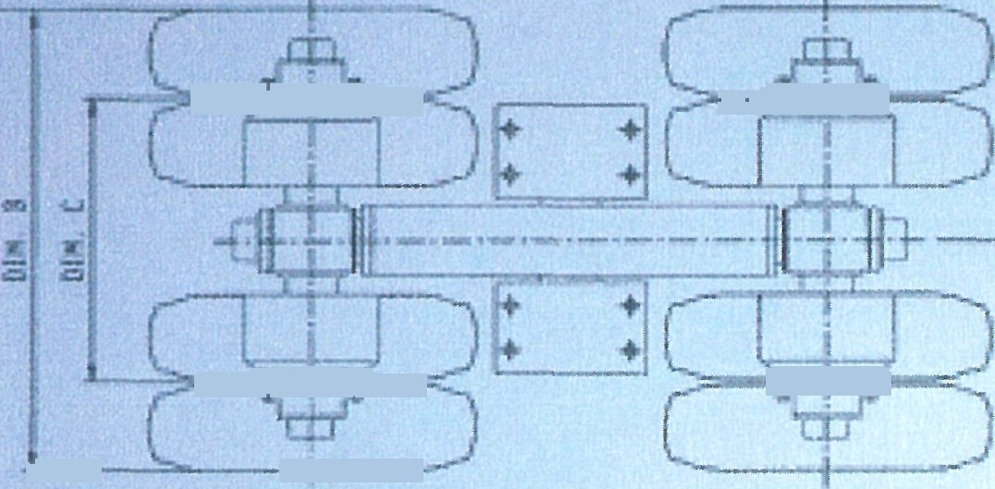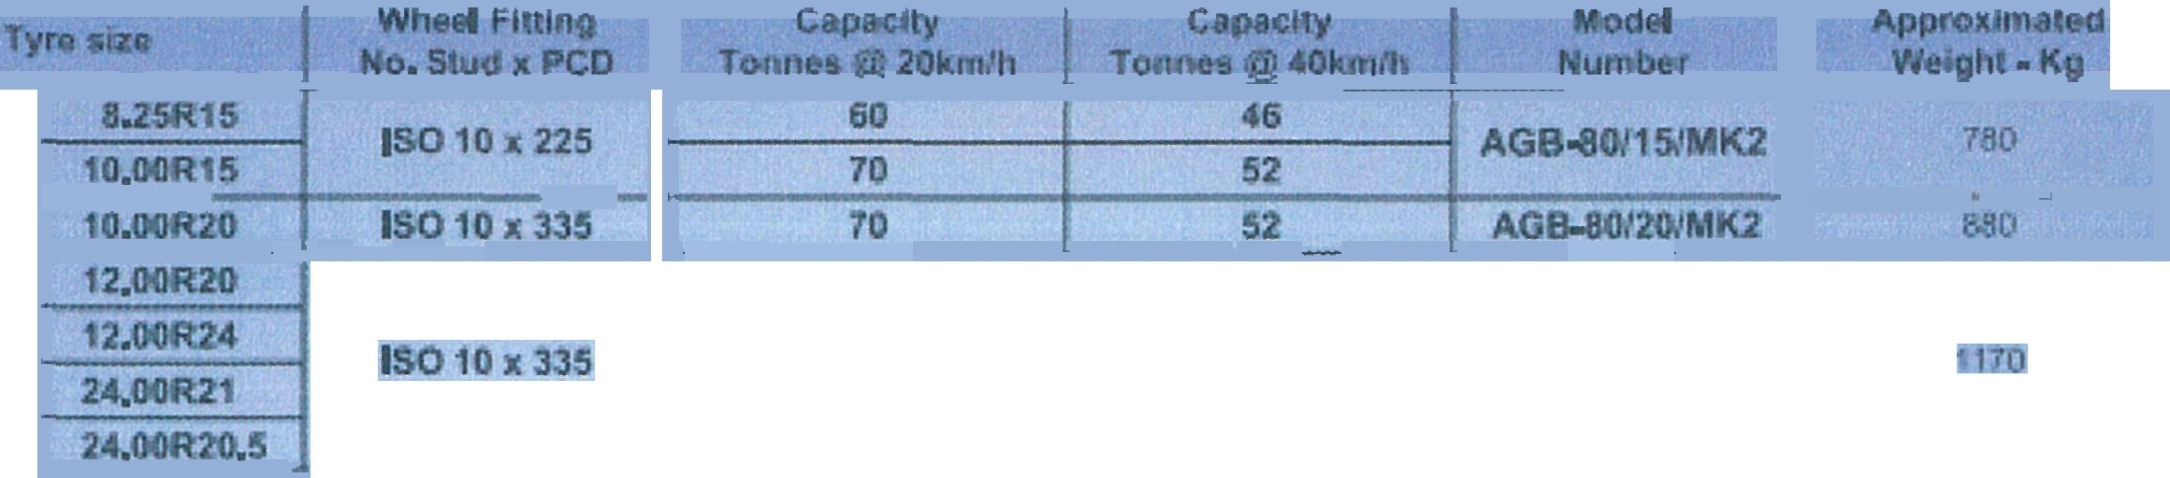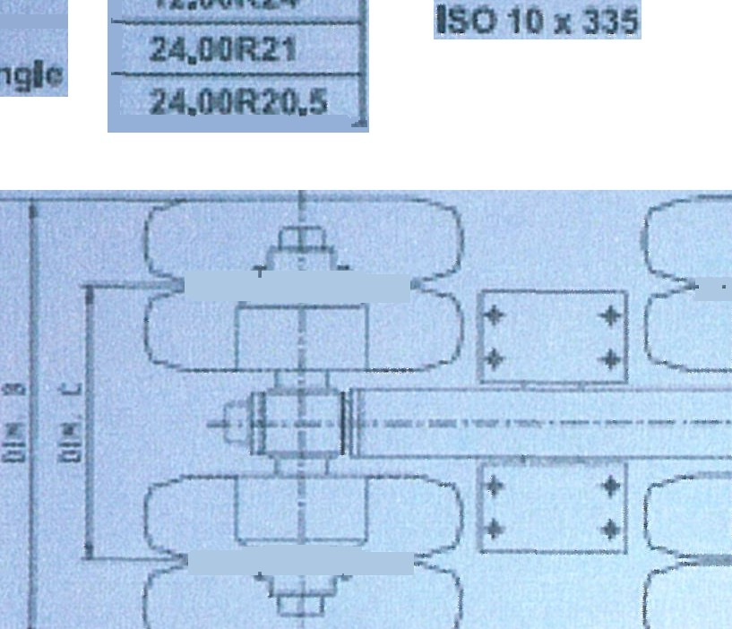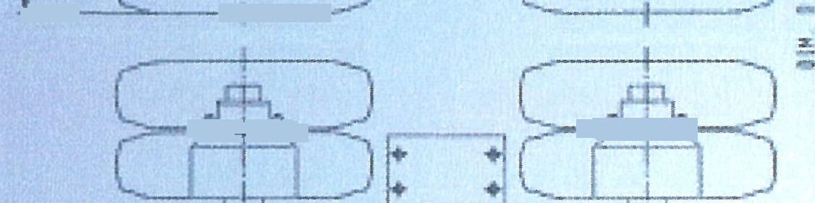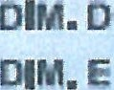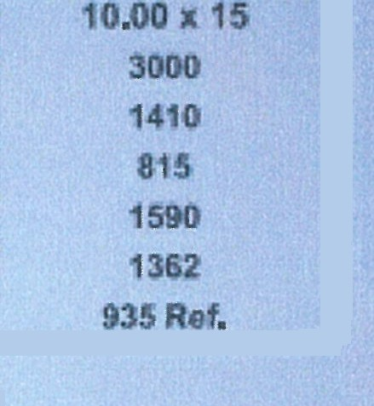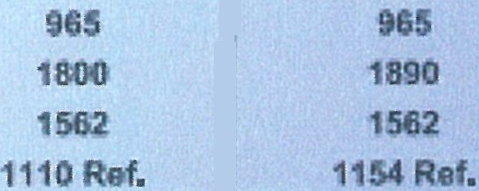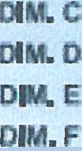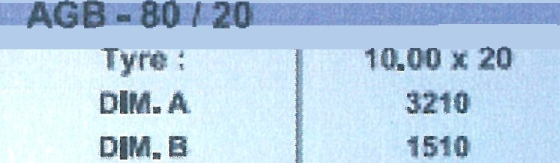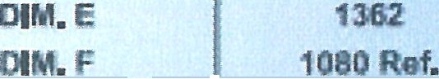

ЯЅ0 ВвЕ

DШ. А DN. В

oa.c

DN. С DЖ. D



ARGONAUT

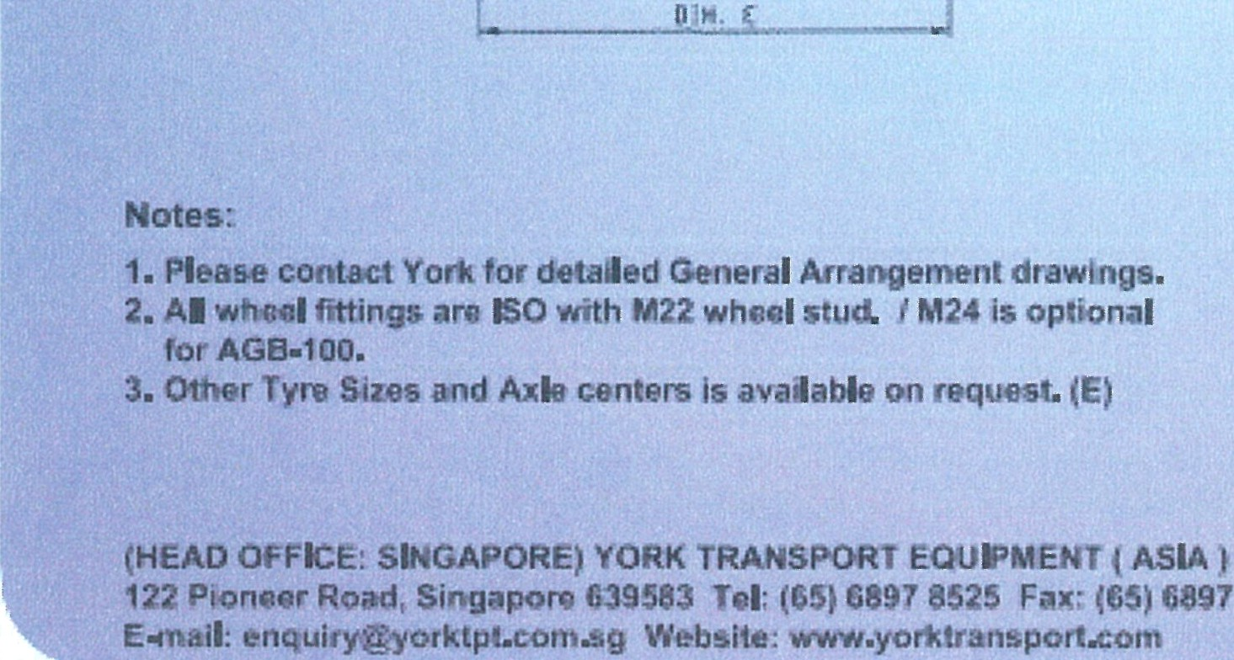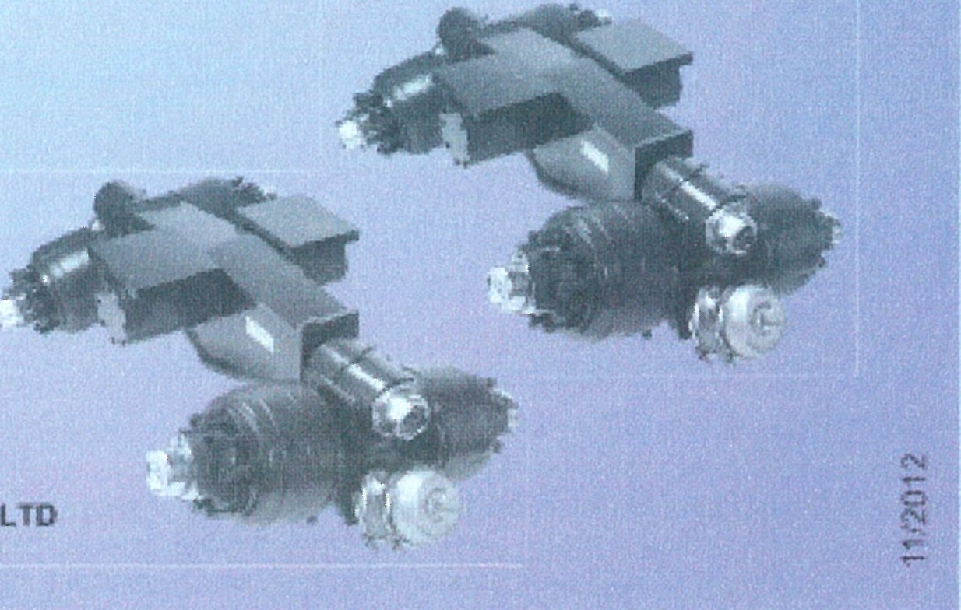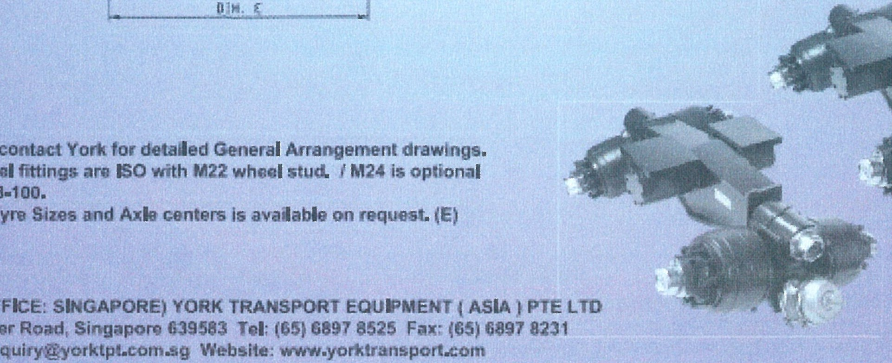

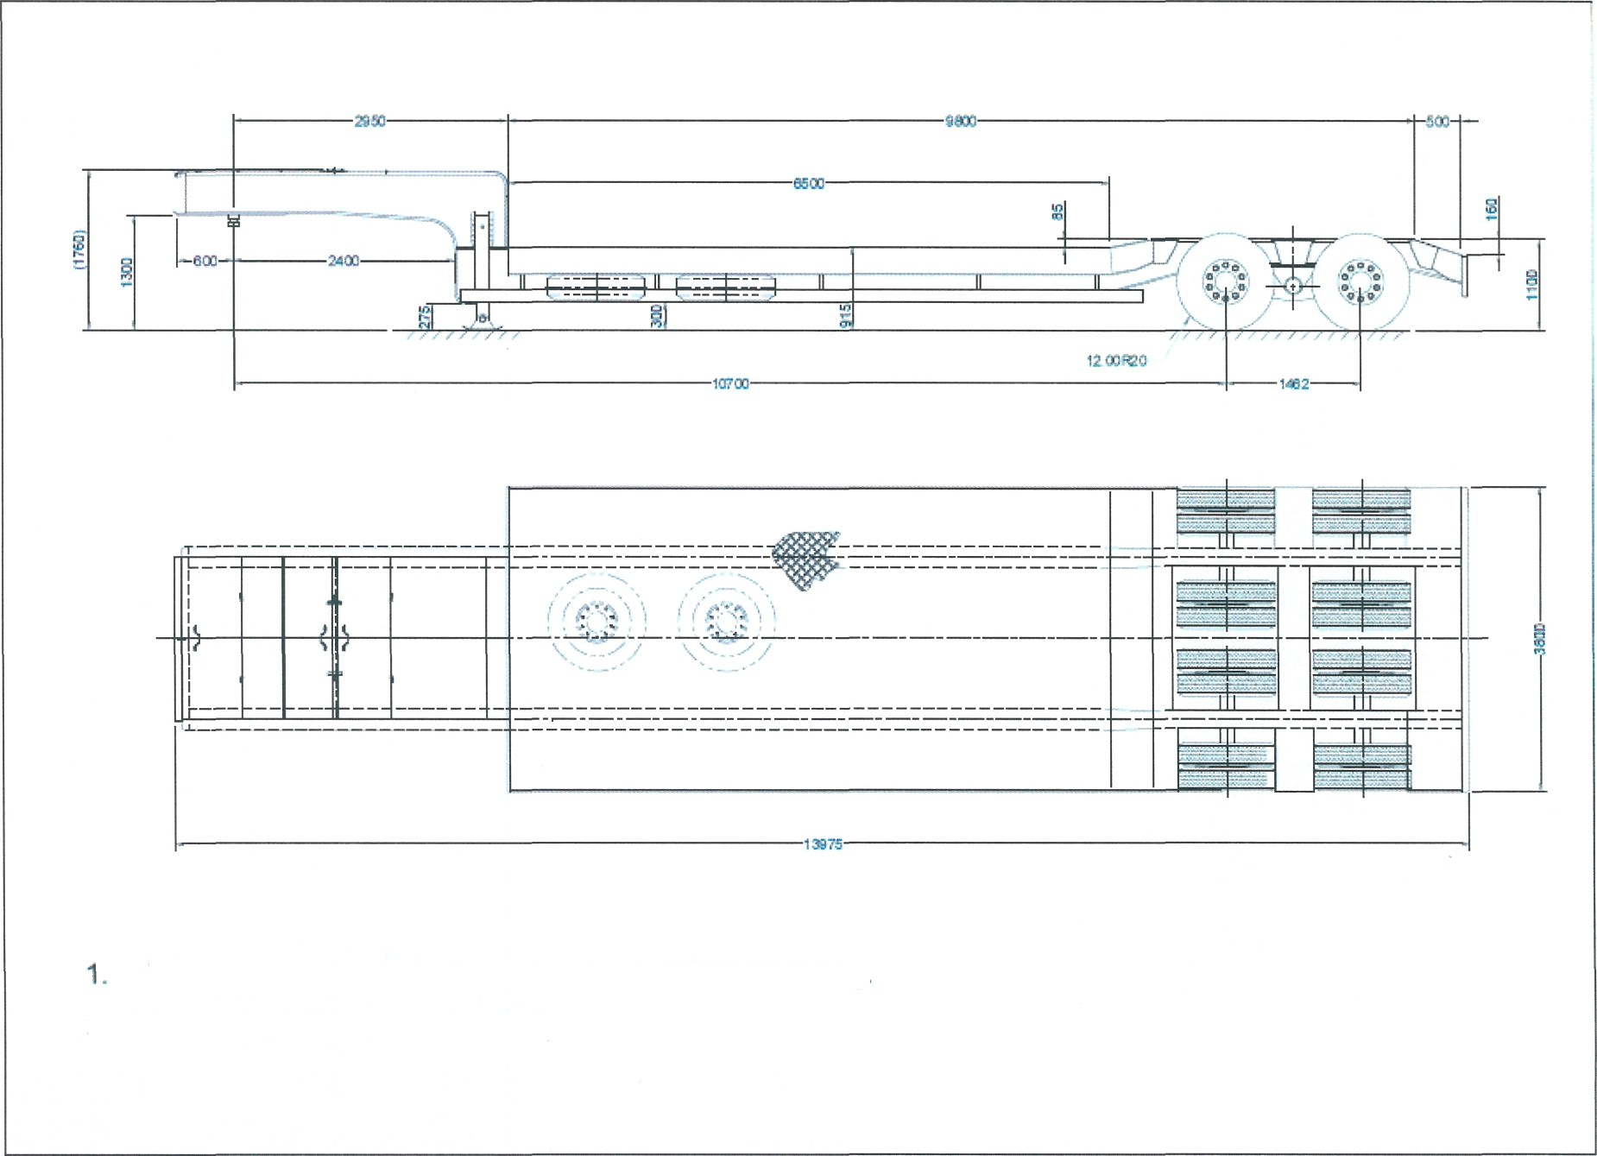Appendix 2: